**GTRI Technical Document**

**Tech Stack Used:**

1. HTML & CSS
2. PHP
3. MYSQL DB
4. XAMPP SERVER

**Tools Used:**

1. Visual Studio Code (IDE)
2. PHP MY ADMIN (To Access DB)

**Note:** Before project setup please make sure that xampp is installed in your locals.

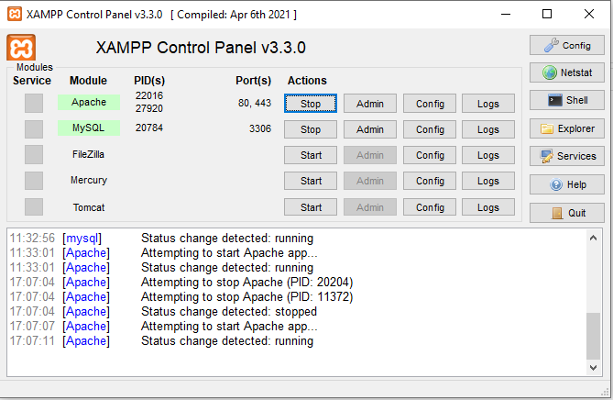

**And Make Sure to start the services of Apache and My SQL as above.**

**Steps for Project Setup:**

1. Using PhpMyAdmin please create a DB with name “**gtri_db**” and import the given database backup file.
2. Extract the Given **GTRI_WEBSITE.zip** file and it will contain below folder structure.

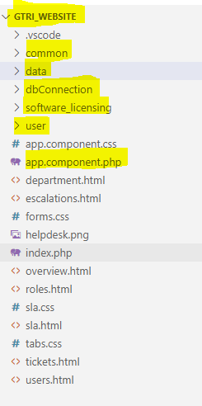

**Project Structure Explanation:**

* From the above snapshot mainly focus on the highlighted folders.

**GTRI_WEBSITE / common:** It consists of two files (common_styles.css, functions.php) which are used frequently in the project.

**GTRI_WEBSITE / data:** It consists of all the files related to “Data” menu.

**GTRI_WEBSITE / dbConnection:** It consists only single file (dbConnection.php) where it will take care of connection UI with DB (MySQL).

**GTRI_WEBSITE / software_licensing:** It consists of all the files related to “Software Licensing” menu.

**GTRI_WEBSITE / user:** This folder consists of files related to user login , registration and logout functionalities.

**GTRI_WEBSITE / app.component.php :** This is the landing page for our application when ever user logins then this page will be displayed at first.

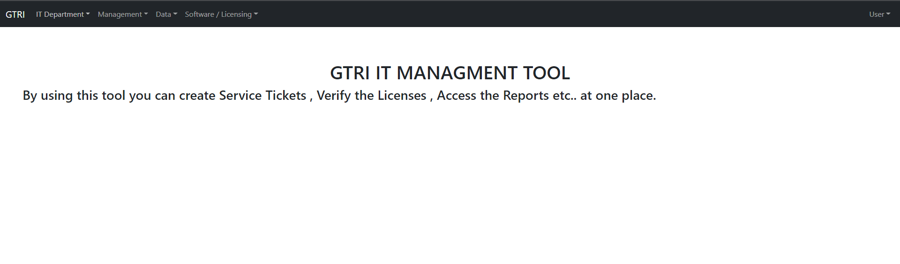

**Code Explanation:**

**Note:** PHP code need to be written only in between following tags “<?php ……………... ?>”.

**dbConnection.php:**

<?php

$servername = "localhost";

$username = "root";

$password = "";

$db = 'gtri_db';

//Create a connection

$con = mysqli_connect($servername,$username,$password,$db) or die("Unable to connect");

?>

We are creating php variables like **$servername** etc… and we are passing variable to mysql_connect() method which will take care of DB connection with MySQL.

**functions.php :** This file will take care of verifying whether user logged in or not. (**Session Management**)

<?php

function check_login($con) // Declaring a function In PHP

{

    if(isset($_SESSION['user_id'])) // $_SESSION is inbuild variable in php which will take care of SESSION Management

    {

        $id = $_SESSION['user_id'];

        $query = "select * from user where email = '$id' limit 1";

// From the above line we are assigning a select to a php variable

        $result = mysqli_query($con,$query); // Executing the Query

        if($result && mysqli_num_rows($result) > 0) // Checking the rows count

        {

            $user_data = mysqli_fetch_assoc($result); // Fetching the data from the query result

            return $user_data;

        }

    }else{

         // redirect to login

        $prevUrl = previousPageUrl(); // calling a function

        $currentUrl = current_url();

        if((strpos($prevUrl, 'app.component.php') == true) || (strpos($currentUrl, 'app.component.php') == true) ){

            header("Location: user/login.php");

            die;

        }

        else{

            header("Location: ../user/login.php");

            die;

        }

    }

}

function previousPageUrl(){ // Declaring a function

    if(isset($_SERVER['HTTP_REFERER'])){

        return $_SERVER['HTTP_REFERER'];

    }

}

function current_url(){

    $url = $_SERVER['REQUEST_URI'];

    return $url;

}

?>

**forms.php :** This page will take care of Service Request creation and inserting the values to database (table called servicetickets).

<?php

  session_start();

  include("../dbConnection/dbConnection.php");

  include("../common/functions.php");

  $user_data = check_login($con);

?>

* Above piece of code will verify whether user logged in or not if not it will not display forms.php it will redirect to login.php.
* And We created a form in this page which will take the inputs from the user and submits them. So, whenever user clicks on Submit button then it will call below php code.

<?php

        require('../dbConnection/dbConnection.php'); // It will call db connection file

        if(isset($_POST['firstname'],$_POST['lastname'],$_POST['department'],$_POST['email'],$_POST['computerid'],$_POST['problemDescription'])){

            $firstname = $_POST['firstname']; // Capture the fields from the forms

            $lastname = $_POST['lastname'];

            $email = $_POST['email'];

            $department = $_POST['department'];

            $computerid = $_POST['computerid'];

            $problemDescription = $_POST['problemDescription'];

            $insertQuery = mysqli_query($con,"insert into servicetickets(firstname,lastname,email,department,computerid,problemDescription) values ('$firstname','$lastname','$email','$department','$computerid','$problemDescription')");

// From the above 5 lines we prepared the insert query and executed it.

  }?>

**Licenses.php:** This file will take care of displaying the Licenses data by fetching from the DB , showing pagination and search functionality for the displayed table.

* Below line of code is on first of the page where it will verify whether user logged or not. If not it will redirect to **login.php** page.

<?php

  session_start();

  include("../dbConnection/dbConnection.php");

  include("../common/functions.php");

  $user_data = check_login($con);

?>

* Below lines of code will fetch the data from the DB table (licenses).

 <?php

if(isset($_POST['search'])){ **// Ignore this IF condition we are not using search functionality using this code**

$valueToSearch = $_POST['valueToSearch'];

$query = "select * from `licenses` where CONCAT(`productname`,`manufacturer`,`purchasedate`,`type`) like '%".$valueToSearch."%'";

$search_result = filterTable($query);

}

else{

$query = "select * from licenses"; **// We are querying the table**

      $search_result = filterTable($query); **// calling a function**

  }

 function filterTable($query){ **// Declaring a function**

    require('../dbConnection/dbConnection.php');

    $getAllLicenses = mysqli_query($con,$query);

    return $getAllLicenses;

}

  while($row=mysqli_fetch_array($search_result))  **// Fetching the Results row by row and displaying in below td’s**

  {

  ?>

     <tr>

     <td><?php echo $row['id']; ?></td>

     <td><?php echo $row['productname']; ?></td>

     <td><?php echo $row['manufacturer']; ?></td>

     <td><?php echo $row['purchasedate']; ?></td>

     <td><?php echo $row['type']; ?></td>

     <td><?php echo $row['quantity']; ?></td>

     <td><?php echo $row['expirydate']; ?></td>

     </tr>

     <?php

     }

     ?>

* How we configured pagination and search functionality.
* We added an id for the table as below

<table id="example" class="table">

</table>

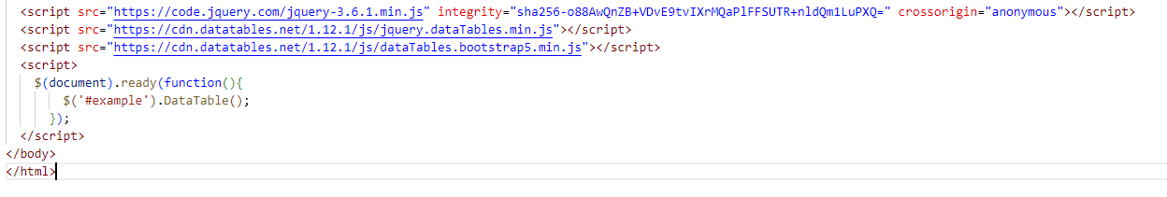

* We need to add above lines at the bottom of the page.

<script>

    $(document).ready(function(){

        $('#example').DataTable(); // We need to pass the id of our table

      });

  </script>

* DataTable() will take care of pagination and search.

**Security.php: Code will be similar like Licenses.php**

**User Registration and Login Pages**

**login.php:** By default if user is not logged in then we will see this login page as default.

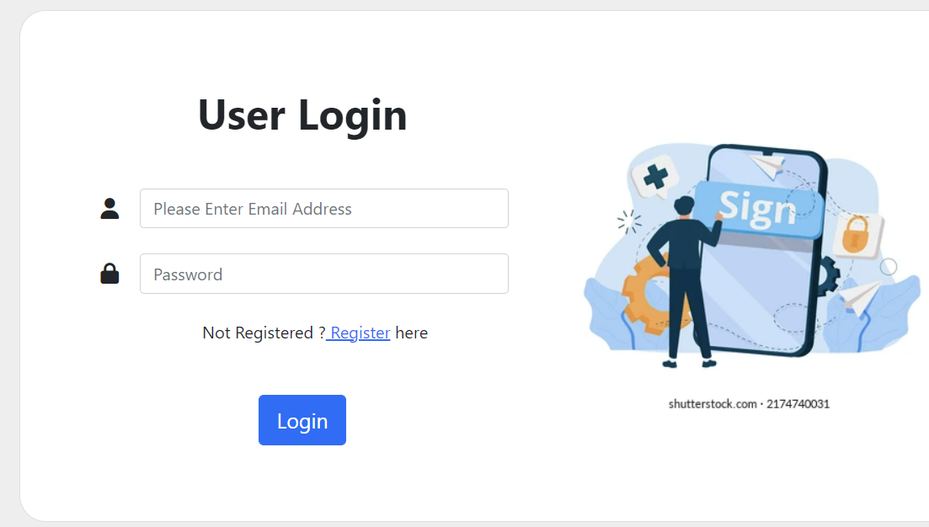

In login page we added a form with 2 input fields where it will take input from the user and submit to the server for authentication.

* Below is the php server code which will take care of authentication.

<?php

session_start(); // Will start a session

include("../dbConnection/dbConnection.php");

include("../common/functions.php");

require('../dbConnection/dbConnection.php');

if(isset($_POST['email'],$_POST['password'])){ **// Checking whether user filled the email and password fields**

    $email = $_POST['email']; // **Capturing the user entered values.**

    $password = $_POST['password'];

    $findUserEmailQueryResult = mysqli_query($con,"select * from user where email='$email' limit 1"); // Written a query whether user exists in user table or not

    if($findUserEmailQueryResult){

        if($findUserEmailQueryResult && mysqli_num_rows($findUserEmailQueryResult) > 0){

            $user_data = mysqli_fetch_assoc($findUserEmailQueryResult);

            if ($user_data['password'] === $password){

                $_SESSION['user_id'] = $user_data['email']; // Setting email id in the session value.

                //header("Location: ../data/forms.php");

                header("Location: ../app.component.php"); **// If successfully logins then we will redirect to app.component page. If not it will stay only in login page**

                die;

            }

        }

    }

}

?>

**new_user.php:** It is a registration page when user registers then it will store the values in users table.

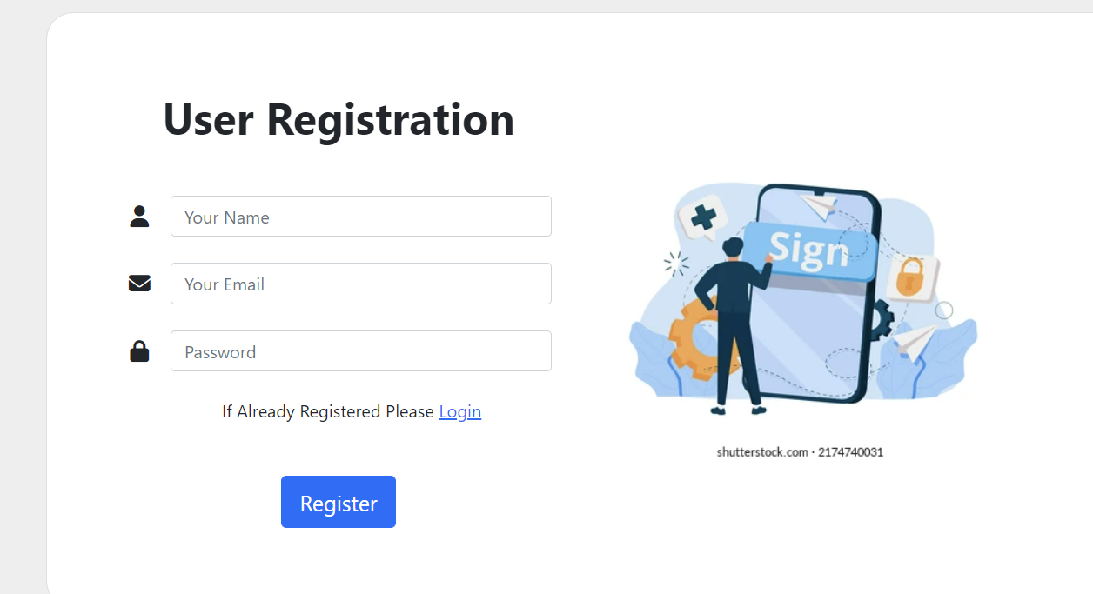

When user clicks on Register button then values will be passed to “**forminsert.php**” page.

<?php

require('../dbConnection/dbConnection.php');

if(isset($_POST['name'],$_POST['email'],$_POST['password'])){

    $name = $_POST['name'];

    $email = $_POST['email'];

    $password = $_POST['password'];

    $findDuplicateQuery = mysqli_query($con,"select * from user where email='$email'"); **// Checking For User Duplicate**

    if(mysqli_num_rows($findDuplicateQuery)==0){ **// If User is not there then it will store the values in user table**

        $insertQuery = mysqli_query($con,"insert into user(name,email,password) values ('$name','$email','$password')");

        header("Location: login.php"); **// After Successful login we are redirecting to login page**

        die;

    }

    else{

        echo '<script>alert("Registration Failed");

            </script>';

    }

}

?>

**Logout.php :** When user clicks on Logout then it will clear the user session from the browser and redirects to login page.

<?php

session_start();

if(isset($_SESSION['user_id']))

{

    unset($_SESSION['user_id']); // Clearing the user_id value from the session.

}

header("Location: login.php");

die;

?>